HARLEY ERNEST FOUNDATION
P.O. BOX 437
PENINSULA, OH 44264-0437

NONPROFIT
U.S. POSTAGE PAID
PENINSULA OH
PERMIT NO.38
a place where residents of boston township and peninsula have shared information for over 30 years

MAY 2020 VOLUME 37 NUMBER 5
RESIDENT 44264

Your Community News is online at www.ycn-online.net

Our flag does not fly because the wind moves it. It flies with the last breath of each soldier who died protecting it.

Unknown

LOCAL

BOSTON TOWNSHIP

The Township minutes are posted on our website at www.bostontownship.org and outside the fiscal office at the Boston Township Hall. Trustee meetings are the second and fourth Wednesday of the month. Zoning commission meets the second Tuesday of the month and the Board of Zoning Appeals meets the fourth Tuesday of the month.

Road Department: The road department continues to mow the sides of roads and keep up with other necessary road work. Brush chipping is the first Monday of the month.
Police Levy: The township’s police levy will be expiring at the end of 2020. The trustees continue to work with the Summit County Fiscal office regarding renewal options. In order to be placed on the November 3 ballot, the township must file with the Board of Elections by August 5.
Zoning Inspector: At the meeting held on April 22, the trustees reinstated John Schneider to the position of Zoning Inspector. John stepped aside last year when an issue arose from a prior employer regarding income earned while on retirement. At that time an acting Zoning Inspector was named on an interim basis pending John’s appeal. As word of his successful appeal was received, John was reinstated to the position.
Zoning Meetings: Zoning Commission and Board of Zoning Appeals meetings have been put on hiatus due to the COVID-19 crisis.

WEBSITE: Visit our Website at www.bostontownship.org to find up-to-date Township information. Contact numbers for the trustees: Amy Anderson: 330-657-2439, Randy Bergdorf: 330-655-5698, and Bill Clifton: 330-657-4032. Fiscal Officer: Catherine Anson at 330-657-2059; Road Department: Dave Krusinski at 330-657-2600; and Zoning Inspector: John Schneider at 330-657-2601 or 234-900-9145.

PENINSULA VILLAGE

Village Council met in an Electronic Meeting Format for the Regular Council Session Via Zoom Meeting May 11, 2020.

April 13, 2020 Regular Council Meeting Minutes were presented and passed as written.

Council passed Resolution 06-2020 A Resolution Accepting The One Ohio Memorandum of Understanding Regarding The Pursuit and Use of Potential Opioid Litigation Settlement Funds.
Council did a second reading on Resolution 07-2020 A Resolution Directing the Summit County Board of Elections to Place a 3 Mill, Five Year, Road Tax Renewal Levy on the November 3, 2020 General Election.
Mayor Dan Schneider announced the appointment of new Zoning Inspector, Chuck Hemming effective May 5.
Cemetery Board Members will be invited to next Council Meeting to vote to continue One Mill Tax Levy for Cemetery Operations.
Memorial Day Parade Activities are Cancelled
Mayor Schneider reminds everyone that if you are planning to remodel your home, new roof, install a fence or retaining wall you will need a building permit. Please call 330-657-2151 for more information.
2020 Census: Households have received official Census Bureau mail with detail information on how to respond to the 2020 Census online, by phone, or by mail. We encourage you to respond as soon as you can. Accurate information directly affects the quality of life in your community.
Reminder to our residents, that it is your responsibility to keep your ditches and driveway culverts clear.
Upcoming Meetings:
Planning Commission May 26, 2020 at 7:00pm Pending
Council Meeting June 8, 2020 at 7:00pm Pending Electronic Meeting Via Zoom
Continued on page two.

EDITORIAL AND PRODUCTION STAFF: Diane and Ray Hach, Marty Griffith, Joanne Palicka, and Father John Terzano. CIRCULATION: Diane and Ray Hach. PUBLISHER: Jack Harley. We welcome your submissions to Your Community News. Concise letters to the editor are more likely to be published; we suggest 300 words or less. Letters must be signed to be printed and may be edited due to space limitations. Information must be received by the tenth of the month to be included in that month’s issue. On-line submissions must include name, address, and telephone number. Please mail to 6780 Riverview Road, Peninsula OH 44264. You may also call 330-657-2439. Preferably, please email to AmyZ1028@aol.com. Your Community News is published monthly except in August and December. Opinions stated may not reflect those of the editorial or production staff of Your Community News. Your Community News is now on-line at http://www.ycn-online.net.

Continued from page one.

Contact Phone Numbers:
Administrative Office 330-657-2151
Non-Emergency Police & Fire 330-657-2911
Check the Website: www.villageofpeninsula-oh.gov

Marty Kuboff, Administrative Assistant

MEMORIAL DAY 2020

I have lived in this community my entire life. From what I can remember, this is the first time in my 76 years we will not have the opportunity to celebrate Memorial Day with parades in Peninsula and Boston. It is unfortunate; however, the absence of a parade should not diminish or minimize the importance of this day. Memorial Day is more than just a parade. It is truly an important day of Remembrance. Not a day to remember battles or wars, but a day to remember those who made the ultimate sacrifice in defense of our nation.
In the 245 years since the first shots were heard at Lexington through today over 1.2 million men and women have died in Military Service to our Country. These men and women were not just some people; they were husbands, fathers, mothers, sons, daughters, uncles, aunts, next door neighbors, guys you played ball with, classmates and good friends. They were just ordinary people who responded in extraordinary ways during extreme times.
And on this day, we pay tribute and show our gratitude to all of these American Soldiers who gave their lives for our Country, for our independence and so that we could all have a better future. In addition, it is important to note that Memorial Day is also about our Freedom, about our Liberty, and about our Sovereignty.
Recent polls indicate that 45% to 50% of Americans do not know what Memorial Day represents. For clarification, there are three important days for military personnel:
- Armed Forces Day is a day that we honor those who currently wear the uniform.
- Veteran’s Day is for those who at one time wore the uniform.
- Memorial Day is the day we honor those who never got the chance to take the uniform off
We hope you will take the time, this year, to pause and remember these heroes, and remind your children and family to do the same.
Although it is not Veterans Day it is important to acknowledge the Veterans that are currently, or at one time were part of our community:
George Fisher – the only remaining WWII veteran in our community that we are aware of
Wayne Alvis
Dave Johnson
Skip Pollitt
Lee Spenser
Johnny Johnston
Joe Kovach
Jim Chadima
Jerry Ritch

It is very possible that this is an incomplete list. We sincerely apologize to any veteran that we may have left off.

Thank you all for answering the call to duty.

Also, it has been a Memorial Day tradition to recognize current and former members of our community that we have lost during the past year:
- Jack Muldowney – A Veteran of the U S Army who served in the Pacific Ocean Theater during World War II.
- Michael Matusz – A Veteran of the U S Marine Corps.
- Alan Cover – Veteran of the U S Navy
- Patty Tesmer – Organized our Memorial Day activities for many years
- Leonard Kaczmarski
- Alice Wierzbicki
- Mary Booth
- Jean Russell
- Lida Flowers Brandt
- Greg Blaze
- Mary Kay (Biz) Feterle
- Don Wolschleger
- Judy Rodatt
- Evelyn Prusak Michael
- Marcy Mercer
- Donna Klaczko
- Glenda Grezlik
- Ione Cook

In closing:
“If you can read this thank a teacher.
If you can read this in English, thank a Soldier.”

Jerry Ritch

MEMORIAL DAY FLAGS

Each year flags are usually handed out to our residents prior to the Memorial Day Parade. Due to the cancellation of this year’s parade there will be flags in containers by the mausoleum in Peninsula and by the maintenance garage in Boston. Please take what you need.

Peninsula Library News

Memorial Day: Even though we will not be able to have our annual memorial service on Storybook Terrace this year, we wanted to remember the former staff, board and volunteers who have passed away since last Memorial Day. We remember:
Anne Alexander
Mary Kathryn Feterle
Lida Flowers-Brandt
Michael Matusz
Marcia Mercer

Library Reopening: The Peninsula Library is currently in the planning stages for reopening the library. The Ohio Library Council (OLC) prepared guidelines for reopening based upon the best advice from health and safety experts. OLC’s guidelines set up a four phase template for reopening libraries statewide. Each library can use the template to fashion a plan to suit their needs. The first two phases, currently underway at Peninsula Library and soon to be completed, involve actions behind the scenes that are not visible to patrons. These two phases involve gathering of materials, equipment and information, instruction for staff, rearranging furniture and other steps necessary to reopen. Phase 3 involves a reopening of the library with the provision of limited services. Most area public libraries will be doing “curbside pickup” for Phase 3. Some libraries with drive-up windows can utilize them for Phase 3. It is not clear at this point how long Phase 3 will last before transitioning to Phase 4 which is a full reopening of the library to pre-COVID norms. Please watch for more information on the Peninsula Library Facebook page or the library’s website at peninsulalibrary.org .

Peninsula United Methodist Church

We are missing our in-person worship with folks! We anticipate that we will soon be hearing about how we can plan future worship services that are safe and spiritually uplifting to our community. With blessings,
Pastor Claudia

HAPPY BIRTHDAY

Special birthday wishes to Nina Alvis who turned 80 years young on May 11.

BELATED BIRTHDAY WISHES

Belated wishes to Lee Spencer who turned 90 on February 1.

PENINSULA MIX

Mother’s Day was different for all of us moms this year. In the past mine consisted of a goodly group going to a restaurant to celebrate. My daughter would pick a restaurant that would not mind small children and a somewhat boisterous group. On Saturday I began bemoaning the changes that have taken over the last few months. I was on the telephone with a dear friend, just ready to complain, when it dawned on me that she had not spent Mother’s Day with her children for a good many years. One is on the east coast with his two children and the other is in the Midwest with her two. This has been her “normal” for a very long time. I am fortunate to have all three of mine right here in the area. One by one, and in shifts, all three came over and we visited in the front yard around a fire pit. Due to social distancing things were different. There was no kiss on the top of the head for J. Tanner nearly brought me to tears when he announced he missed spending the night with us, and Angeline, too little to know what was going on, raced up and down the hill exclaiming “I’m coming Gamma”. That evening it dawned on me, the majority of my friends do not have children that live in this area. I need to count my blessings. We can only hope next year we will be back to normal.

I hope you are all enjoying the beautiful Redbud trees in full bloom. The most wonderful grouping is on Hines Hill Road at the old Schmidt home. The Dogwood trees are just beginning to bloom. It is time to remember Ralph Reinhart, Sr. who, for many years, gave away seedlings to all of the school children in the community. Mr. Reinhart switched to Redbuds when a blight made it difficult to obtain Dogwoods. Many of those in bloom are the result of his efforts.

Lindsay Ward has two new books, Let’s Draw and Color: BUGS. and Let’s Draw and Color Construction Vehicles. Lindsay and her husband, Frank Tupta, are the authors of many children’s books. Let’s Build: A Flip-and-Find-Out Book will be available June 16. The Importance of Being 3 makes a great gift. I’m saving this one for Angeline’s next birthday. These are all available at local book stores as well as on Amazon.

Regardless of social distancing we all have occasions to purchase gifts. Please remember many of the area business when shopping. There are many artists who participated in our Community Christmas Bazaar that you can reach on Facebook or their websites. Bella Volpe has beautiful jewelry, Hope Soap Ohio has a good selection of bath items, and Traveling Juniper has a variety of items including face masks.

Pierogi’s of Cleveland has reopened their Richfield location. To go dinners as well as frozen items may be purchased. They are located at the corner of Routes 303 and 21.

A Community News welcome to Nick Janigan. Nick recently purchased Ron and Biz Feterle’s home on Stanford Road. Many of you have already met Nick. He purchased the old Boston Community Church. Nick’s mom, Jessica helped us out last Memorial Day by providing food and the most wonderful baked goods at the church location.

Happy Birthday Nina!
Amy Anderson
condolences

Former village resident Anne Alexander passed away February 28, 2020. While living in Peninsula, during the 70’s, she operated the Drawing Room. The Drawing Room was located next to the popcorn shop. Local arts and crafts were sold and well as offerings of lessons. This was a precursor of sorts to the Art Academy.

Marianne Georgeoff passed away April 4, 2020. Many of you know her through DMT Motors, the family business. Mrs. Georgeoff is survived by her children, Cheryl Blaser, David, and Thomas.

Irene Szalay Kusnyer passed away April 15, 2020. Mrs. Kusnyer graduated from Boston Township High School in 1940 and enjoyed spending time at Szalay’s Sweet Corn Farm, the family business. She is preceded in death by her husband Ernest, Parents, Big Jim and Eva Szalay, Brothers John (Helen) Szalay, Paul (Moncie) Szalay and sister Mary. She is survived by her sons Arthur (Judy), James (Marcia), Ernest (Jill), and Andrew (Nancy).

Donna Klaczko passed away April 25, 2020. She was preceded in death by her father Stanley. She is survived by her mother Patricia and brother Gary

Glenda Grezlik, age 76, passed away April 27, 2020 after a lengthy illness. Glenda was a good friend to the community and helped with many community events including the Community Christmas Party. While her children attended Woodridge Schools she was very active in the PTA. Glenda was preceded in death by her husband Jim. She is survived by children, Frank (Christina), Kellie (Robert) Zajac, and Kimberly (Brent) Bucey as well as seven grandchildren.

Ione Cook, age 98, passed away May 3, 2020. Ione was a member of the Peninsula Methodist Church and the Peninsula Garden Club. Preceded in death by her husband, Bob, she is survived by children Gary, Sandy, Judy, and Bobbie.

David Ridenour passed away May 5, 2020 due to a sudden illness. He is survived by his wife Janie Bauza Ridenour.

Helen Hiatt, age 97 passed away May 9, 2020. Mrs. Hiatt was preceded in death by her husband Roland and is survived by her son, Darrell.

Mother of Sorrows Reopens

Since mid-March, churches across the eight counties of the Catholic Diocese of Cleveland, including Mother of Sorrows, have suspended public Masses due to the coronavirus pandemic. Beginning on Memorial Day, May 25, daily Mass will resume at Mother of Sorrows. Mass will be at noon. Please check the parish website, motherofsorrowspeninsula.org, for the schedule of Masses for the rest of that week. The weekend of May 30-31 will mark the Solemnity of Pentecost, with the usual weekend Mass Schedule of 5:00PM on Saturday and 8:30AM and 11:00AM on Sunday. We will follow protocols of social distancing. This will limit the number of people that will be able to attend Mass. Those coming to church will have their temperature monitored, are to use the hand sanitizing stations and wear masks. The church will be sanitized before and after each Mass. These protocols will help keep everyone safe as we begin to come together again. Please consult our parish website for details or call 330-657-2631. Thank you for helping us come back together to worship at Mother of Sorrows.

Father John Terzano

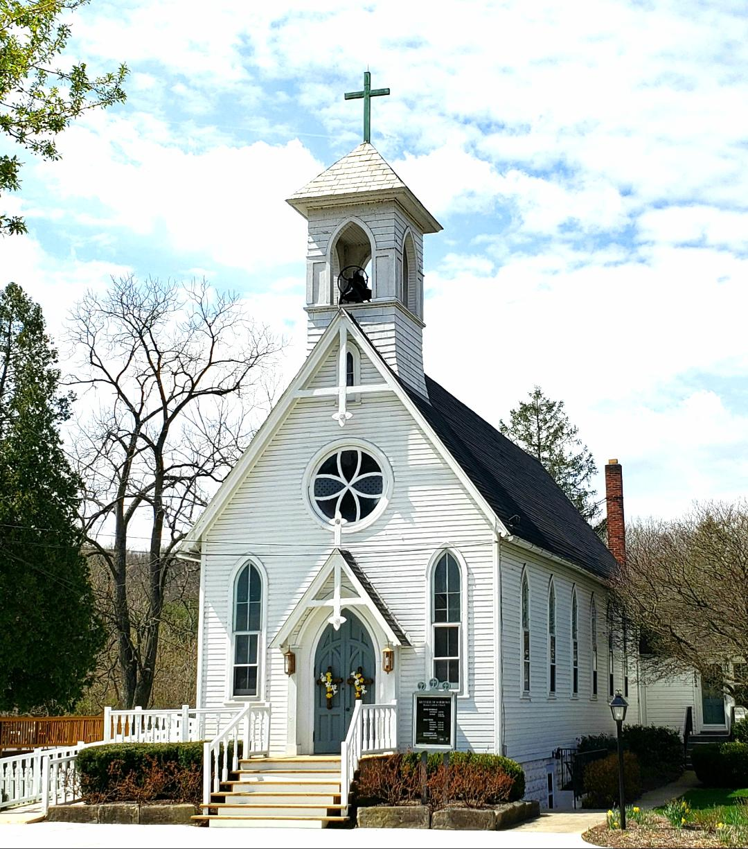

WOODRIDGE RECREATION

Woodridge Recreation would like to update everyone on what is going on.
At this time we have to cancel our spring/summer soccer and baseball. Softball is still up in the air. We will advise as soon as a decision has been made.

We also have couple fundraisers going on.

We are doing a mulch sale through Earth and Wood.
If you go there and buy or order by phone just mention ordering on behalf of Woodridge Recreation Association for us to get credit. If ordering online use promo code WOODRIDGE for us to get credit.
EARTHNWOOD.COM

Also on the LAST Thursday of every month if you order from Marco’s pizza BY PHONE or ONLINE!! We then get a percentage of your purchase.

There are 3 Locations:
430 Portage Trail, Cuyahoga Falls 330-928-8888
3707 Darrow Road, Stow 330-686-6888
2747 Manchester Road, Akron 330-753-2300

If ordering by phone just mention Woodridge Recreation Association
If ordering Online:
To make sure we get credit please follow these steps:
1. Place your order as normal then click "FUNDRAISERS" under the menu...look for Woodridge Rec Association select and then click "Add"
2. No need to select a teacher
3. Check your cart you should see Woodridge Rec Association.

THANK YOU FOR YOUR SUPPORT!!!

I Wonder

I begin this note with a quote;
“Without God there could be no American form of government, nor an American way of life. Recognition of the Supreme Being is the first, the most basic expression of Americanism. Thus, the founding fathers of America saw it, and thus with God's help, it will continue to be.”
Dwight D. Eisenhower - 1890 – 1969
One person I listened to since my last note said that the reason we have much fear is because of our insecurities. The idea was that if this world is all there is, then we will be desperately to try to preserve our lives at all costs. He observed that if you exclude God from your life there isn’t anyone or anything that can provide you the security you know in your heart that you need so you can face an uncertain future. The Provider of that security must be greater than anything we can think or imagine and make Himself known in my life. In my case it was when I made a decision to become a Christ-follower. I can trust Him and rest securely in His care for me knowing that He knows what He wants to accomplish through me even if I doubt or don’t understand. I may have just made it sound easier than it is to live out, but that decision created a tension that is a daily struggle to keep in touch with Him and do what He asks.
The reason I wrote last month was to get you to think about our current restricted liberties. You perhaps thought that I was being selfish (which some part of it probably was) but my goal was to get you to think about all of the good things you did before you had to stay home. As a Christ-follower, I am loved by God so I can pass that love along to others. Being healthy and confined to my home didn’t seem to me to be very helpful to others when there are vulnerable populations which needs the help of healthy people. On top of that, Christ-followers now and across the ages have run into danger to help others in the name of Christ to bring them some comfort even sometimes at great personal cost. There is a sad statistic in the New York Times about nursing homes & other care facilities across the US; 35% in those facilities have died because of the virus; it is even higher, up to 50% in places like New York. I wonder what would happen if those of us that are healthy and willing, mobilized and protected them somehow using the wisdom and guidance by God and good solid scientific facts, not the ones that seem to keep changing. Instead we are told to stay home.
There is a ministry called Care On The Square that was started by a husband and wife to feed the homeless in downtown Cleveland quite a number of years ago and I am part of a group that prepares food for them once a month. They have not missed a week to feed the homeless. What would those homeless do if COTS decided to stay at home? I wondered if those homeless ever thought that they might not show up? I really would like you think about ways you might be able to help. Not by being de-mobilized but by mobilizing! I am sure there are some that are already doing as my friends do with COTS. Is there risk? Sure, if we only make a difference for one, it would be worth it.
So, circling back to the quote I used, Eisenhower believes there is a vital connection between a strong belief in God which expresses itself through Americanism. I agree with him because we need Someone who we are able to depend on when things around us don’t look so favorable so we are still able to serve others.
I hope I gave you something to think about.
And two more Eisenhower quotes, one for those of you who prefer to remain under the current house arrest and another I thought was interesting;
“If you want total security, go to prison. There you're fed, clothed, given medical care and so on. The only thing lacking... is freedom.”
“Only Americans can hurt America.”
Ray Hach
ray.hach@juno.com

LOCAL BUSINESSES

As we go to press the following list has been provided by the Peninsula Foundation.

- Appalachian Outfitters: Open Visit appalachianoutfitters.com/pages/appointments
- Century Cycles: Open Mon-Sat: 10:00AM to 6:00PM; Sun: Noon to 5:00PM
- Crooked Kettle Popcorn Co: Open weekends, call 330-657-4026 for hours
- Fisher’s Café: Open Wed-Sun: 11:00AM to 8:00PM for curbside pickup and delivery, call 330-657-2651
- Heritage Farms: Open for weddings, vacation rentals, tent camping, Peninsula Flea (6/6)
- MBA Design: Call 330-657-2335 for appointment
- Ohio Hardwood Furniture: Open Wed, Fri: 10:00AM to 6:00PM; Thu: 10:00AM to 8:00PM; Sat: 10:00AM to 5:00PM; Closed Sun-Tues
- Pedego Peninsula: Open Wed-Sun: noon to 6:00PM, Mon-Tues by appointment
- River Light Gallery: Open by appointment and for grab and go; Open Sat-Sun from noon to 3:00PM beginning May 23.
- Terry Lumber & Supply: Open Mon-Fri: 8:00AM to 5:00PM; Sat: 8:00AM to noon; Closed Sun
- Trail Mix – Peninsula: Open by appointment, curbside pickup, and new online store: conservancyforcvnp.org/online-store
- Winking Lizard: Reopening May 21 daily from 11:30AM to 9:00PM
- Yellow Creek Trading Co: Reopening May 20, Wed-Sat: 10:00AM to 5:30PM, Sun noon to 5:30.

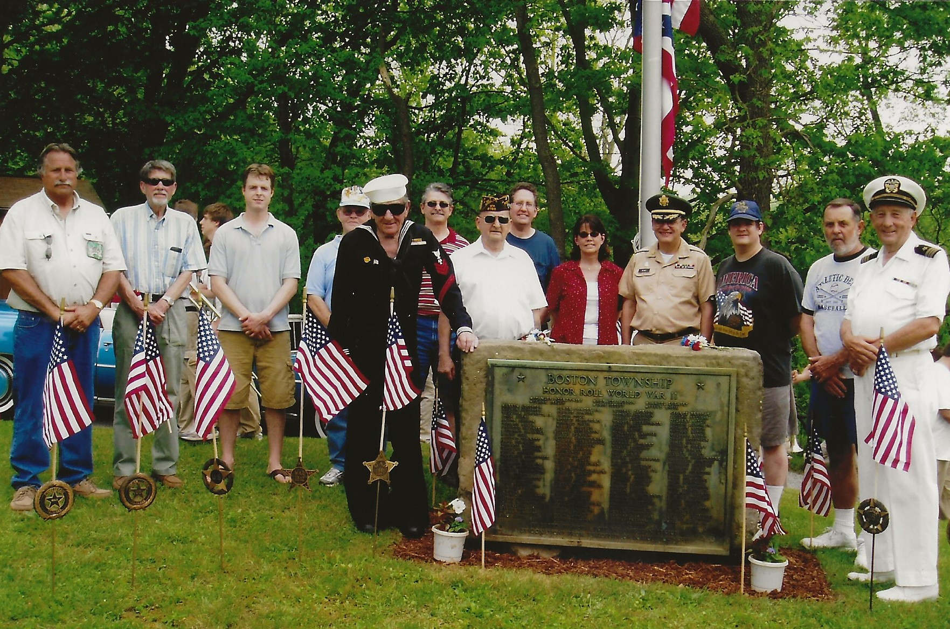

Memorial Day 2006
Boston Cemetery

Memorial Day 2011
Boston Cemetery

Memorial Day 2006
Boston Cemetery

Dave Georgeoff, who lovingly cares for Jack Russell’s Cadillac, escorts Willie Ritch (Navy uniform) and Chic Tesmer at the Boston Community Church.

Wastewater Committee

A PowerPoint presentation has been created to continue communication with the community regarding the Village of Peninsula’s current alleged violations of the Clean Water Act, and the eventual response.
This PowerPoint is located in the Village of peninsula Website. http://villageofpeninsula-oh.gov/
Please take the time to read and study each one of the slides in this presentation.
All correspondence, questions and comments will be utilized to help form the final recommendations of the wastewater committee.
If you have questions or concerns please forward them within the next 30 days to: Mr. Martin F. Kuboff, Administrative Assistant, Village of Peninsula, admin@villageofpeninsula-oh.gov
Mr. Kuboff will forward your questions or comments to each member of the Wastewater Committee. Your questions and the response from the Wastewater Committee will be added to this presentation and made available for others to consider

our valley

I’ve heard a lot of stories about “Why we came to the valley”, and most of them are fun to hear, because they mostly have to do with people who were searching for something different that they could afford, and they were trying to live a better life than they were used to.

People in Akron that we knew thought that Marilyn and I were nuts to think about coming here.

We would hear “Isn’t that near the Botzum sewage treatment plant? Does it smell a lot up there? They may have had sympathy for our misguided judgement.

On my first visit to Peninsula, I stopped at the original Fisher’s, restaurant, which was little more than a large diner with a swoopy roof. Inside, a crabby old man was working behind the counter.

I asked who the crabby old man was, and someone said “That’s George Fisher. He’s the mayor.” George’s bite wasn’t as bad as his bark, and we learned to like George Fisher.

The folks we met in town were a little strange, but never boring.

In those days, you didn’t need to be rich to live here, and I think that had something to do with the fact that the people we met were not “Same old, Same old.”

The house that Marilyn and I bought was little more than an overbuilt cabin. We needed more room, but we didn’t have much money, so we had to do most of the work ourselves.

That’s when we met Fred Urbank, a handyman who could do anything, from lens grinding to making home brew to taxidermy.

Fred was installing a water pressure tank for us on a Sunday afternoon, when he said “I’ve got to go to Terry’s to get the parts.”
I reminded Fred that it was Sunday, and Terry’s was closed. Fred smiled, and reached in his pocket, and said:

“I’ve got the key”.

Marilyn said “I didn’t think that there were any people left like that.”

I bet no one but the owners had keys to stores in Hudson or Brecksville.

We still feel we are lucky to live here, and we at the Community News ask our readers to tell us why and how you came to live in the valley. Help us preserve our history!

Marty and Marilyn Griffith

Services are online this month.

services

TREE TRIMMING: Tree trimming, storm clean-up, general clean-up. Call Tom the Tree Guy at 330-760-4105.

Sonshine Cleaning Service: Residential (including Apartments), Commercial, Offices, Floors, Walls, Windows, Bathrooms, etc. $10 off first cleaning and $10 off for every referral that uses us. Three hour minimum please. Please contact Claudia Norris at (440) 915-9957. Local references available.

LICENSED ELECTRICIAN- Peninsula resident. Great rates/Quick service. Call Steve at 330-310-1061.
Ohio license #El22934.
COMPANION SERVICES: Are you a senior seeking senior companion services? Well, help is here. Call Kimberly for more details. 330-285-6962

Local Certified Mechanic, Peninsula (six years)
Mechanical/ Electrical/ Lite Body Repair/ and Full Vehicle Detailing, Seven days a week, by appointment only. Very Professional with references if needed. All work comes with a one year warranty. Anthony Bruce 330-907-7287. Very text friendly.
YCN reader rating of 5 stars! Good work – Good Auto Mechanic!

REAL ESTATE SERVICES: Your hometown Real Estate agent. Looking to buy or sell your home? Call us. Sylvia Tonhaeuser/ Robin Shrader Remax Trends 330-329-1851. No one knows Peninsula or Boston Township better.

PROJECT FEEDING KIDS: Find the best prices for
every essential service, both residential and commercial, while helping feed children in the community. We work with top brands, such as DirecTV, Dish, AT&T, Verizon, Sprint, gas, electric, and merchant services. Call Kelly at 330-203- 9713.

CARPET, RUG, UPHOLSTERY & TILE CLEANING: Citrus-based green cleaning system. Safe for children and pets. No residue and dries in a few hours. Offer 20% discount includes moving couch and chairs. Contact Sandy or Jim Sadens at 330-657-2113 CitrusGreenClean.com Email us at sadens.jim@gmail.com
YCN reader rating of 5, multiple community comments.

NEED A HAND? CALL THE HANDYMAN! Bath resident, Joshua Kastelic, 15+ years experience. Honest, Quality, On-Time 330-289-8181 thehandyman_can@rocketmail.com
YCN reader rating of 5, reporter has used this service multiple times.

PET SITTING IN YOUR HOME: For all your pet sitting needs, contact Precious Pets Sitting Service at 216-701-4181. Providing visits, midday walks, and overnight service since 1997. Rates start $18/day, insured/bonded, Veterinary
Technician.

PHOTOGRAPHER: Your photographer neighbor
www.KelleyWeitzelPhotography.com For all photography needs.

LICKITY-SPLIT: Firewood, tree cutting and wood splitting. Call Scott Ensign at 330-657-2462.

ALEXANDER WATER: 330-923-0014.

Custom Picture Framing: Award-winning custom picture framing since 1992, with framing consultations at your home or office, delivery and installation. Instruction with social media and marketing. Fine Art Services - Assisting artists, designers, corporate & residential clients in the selection, display and proper framing of art. 330-657-2228.
YCN reader rating of: 5 Star Rating! I have used Carolyn to frame, reframe, and repair all sorts of art for me and she does a professional job.
YCN reader rating of: 5 Star Rating! Wonderful work and very creative. Highly recommended.
Sawmill Service: From firewood to tree removal, all the way to decks, porches, & more. We do it all, give me a call! Wells Construction/S & S Sawmill, Seth, (330) 352-0210.
YCN reader rating of 5, reporter very pleased with services.

FOR SALE: End Tables and Coffee Tables. Eye-Catching, Locally Sourced Hardwoods. Handmade in Boston Township. Visit www.studiojoe.us.

