##### Parish Schedule

##### and Mass Intentions

**July 8 Saturday** Weekday; BVM

**5:00pm Mass** *(Thomas Sylvester)*

**July 9 *Fourteenth Sunday in Ordinary Time***

**8:30amMass** *(People of the Parish)*

**11:00am Mass** *(Gertie Zgodinski)*

**July 10 Monday** Fourteenth Week in Ordinary Time

**8:30am** **Mass** *(Theresa Holland)*

**July 11 Tuesday**  St. Benedict, Abbot

**8:30am** **Mass***(Dante and Lucietta Terzano)*

**July 12 Wed.** Fourteenth Week in Ordinary Time

8:00pm AA Meeting (Church Hall)

**July 13 Thursday** Weekday; St. Henry

**8:30am Mass** *(Kyle Bretz, Birthday Blessings)*

**July 14 Friday** St. Kateri Tekakwitha, Virgin

**8:30am Mass** *(Reverend Robert W. Donohoe)*

**July 15 Saturday** St. Bonaventure,

Bishop & Doctor of the Church

**4:00pm Sacrament of Reconciliation**

**5:00pm Mass** *(Thora Montaquila)*

**July 16 *Fifteenth Sunday in Ordinary Time***

**\* 8:30amMass** *Henry “Hank” Pugel, d. 7/17/2016*

**\*11:00am Mass** *(People of the Parish)*

***\*Sunday Birthday Breakfast***

***Birthday blessings and wishes to all who share a birthday in July, for me it will be my 70th. Why not join in fellowship and sharing your life’s stories as you like Sunday, July 16th after the *8:30am and 11:00am Mass? We will gather under the tents set up in front of the rectory and also in the church hall. Those with birthdays during the other 12 months of the year are also most welcome to celebrate! Come,***

***celebrate your birthday with fellow parishioners. Many happy returns!***

**General Intercessions**

**For those who travel this weekend, that they might be refreshed in the company of friends and loved ones and exercise good judgment in their recreation and travel. Let us pray to the Lord.**

**Scriptures for Week of July 9, 2017**

**Sunday** Zec 9:9-10/Rom 8:9, 11-13/Mt 11:25-30

**Monday** Gn 28:10-22a/Mt 9:18-26

**Tuesday** Gn 32:23-33/Mt 9:32-38

**Wednesday** Gn 41:55-57; 42:5-7a, 17-24a/Mt 10:1-7

**Thursday** Gn 44:18-21, 23b-29; 45:1-5/Mt 10:7-15

**Friday** Gn 46:1-7, 28-30/Mt 10:16-23

**Saturday** Gn 49:29-32; 50:15-26a/Mt 10:24-33

**Sunday** Is 55:10-11/Rom 8:18-23/Mt 13:1-23



***Read and pray***

***the Scriptures daily.***



From the

**Pastor’s** **Desk**

**On this 14th Sunday in Ordinary Time Jesus speaks to all who will acknowledge a need to rest. Sunday is meant to be a day of rest. Sunday is a day to find our life made new in God. God has given us life and all that is good. May we come to the Heart of Jesus, lay down our burdens, rest and learn from the One who is “…meek and humble of heart…(Matthew 11:29)” yet by His love lifts us up from all that would burden or crush us. Let us trust such love and be at peace. May the blessing of genuine Sunday rest be upon each of us. Let us pray…**

***O God, Who in the abasement of Your Son have raised up a fallen world, fill your faithful with holy joy, for on those you have rescued from slavery to sin you bestow eternal gladness. Through our Lord Jesus Christ, your Son, who lives and reigns with you in the unity of the Holy Spirit, one God, for ever and ever.***

***Amen.***

***Collect, 14th Sunday in Ordinary Time, Roman Missal, 3rd Edition***

**What is God Asking of You?**

**There are life decisions and daily decisions in which we are to discern what God is asking. In His Will is our peace. In other words, answering the question daily: “Lord, what is Your Will for me?” A Franciscan priest, Albert Haase, OFM, a popular parish mission preacher, teacher, spiritual director and radio host will be with us at Mother of Sorrows hall via DVD presentations. Mark your calendars for Thursdays from 7:00pm - 9:00pm starting July 20 and concluding on August 10. For more information call 330-657-2631.**

**Please pray for…**

*****Ann, Violet Benich, Richard Bennett, Celia Bican, Dennis Babb, Logan Boone, James Brigotti, Heidi Burmeister, Johannah Conner, Frank, Millie Fritz, Tom Gardner, Chris and Laura Gibbs, James Ging, Marilyn Griffith, Angie Grimes, Jennifer Grimes, Tayha Hostetler, Carol Irving, Kathy James, Ellen Jansen, Jill, Kathleen Jones, Maureen Joyce, Marca Kaplar, Helen Kracker, Carol Leach, Ramona Lucas, Paul Marcene, John McDermott, Megan, Annalisa Menke, Audrey Menke, Menke Family, Bill Misencik, Marjorie Morgan, Molly, Ashley Munoz, Natalie, Nate, Carroll O’Donnell, Richard Edward and Richard William Parker, Anika Patrick, Bridget Perez, Michael Phillips, Jacqueline Polcen, Edna Raber, Rita, Bruno Ruppel, Rosanne Sanford, Bonita, Steve Sheets, Theresa “Tess” Slenn, Miriam Sommers, Stephen Sommer, Shirley Southard, Amy Stephen, Paul Stephen, Bruce Styles, Marla Sliwinski, Patty Tesmer, Laura Tories, Marianne, Stephen, Dylan Trecaso, Mallory Trecaso, Paul Trecaso, Sylvia Trecaso, Patricia Wiatrowski, and all those who are in need of our prayerful support…Amen.***

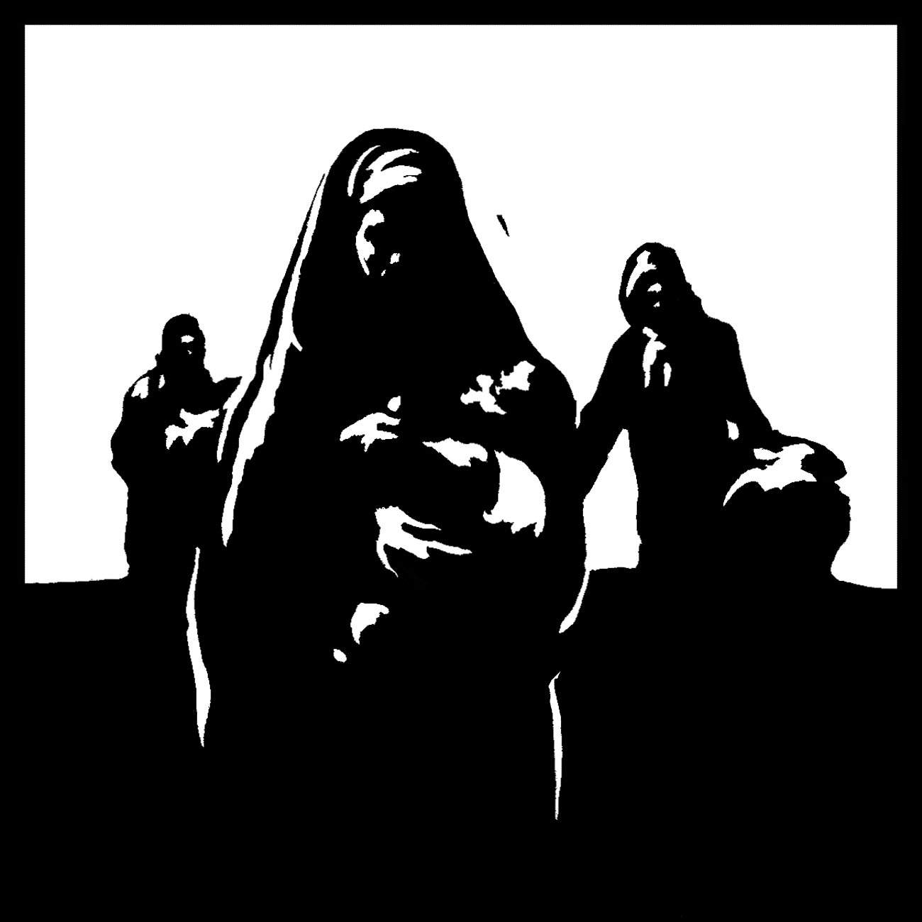***July 9, 2017***

***14th Sunday in Ordinary Time***

*"Come to me, all you who labor and are burdened, and I will give you rest." Matthew 11:28*

**There’s Hope**

**Many in our region are struggling with the pain and devastation caused by the heroin epidemic. There is always hope and pathways to find help. If you, or someone you know, is struggling with addiction or needs help in supporting a family member, visit** [**www.GreaterthanHeroin.com**](http://www.GreaterthanHeroin.com)**.**

**Pope Francis Requests: Take the Youth Survey!**

**The Catholic bishops of the world are planning to meet in October 2018 for the 15th Ordinary General Assembly of the Synod of Bishops. The theme of this gathering is “Youth, Faith and Vocational Discernment.” In preparation for this major synod on youth, Pope Francis wants to gather input from the Catholic faithful. Consequently, the Diocese of Cleveland has made available a survey questionnaire to gather information on the current state of the young in our diocese that will be included as part of the pre-synod discernment document. The survey can be found on the diocesan website home page,** [**www.dioceseofcleveland.org**](http://www.dioceseofcleveland.org)**. All are invited and encouraged to participate by taking this short survey. The bishops of the United States pray that the results of this survey will help them more fully understand the experience of young people in our Church and in our country -- their hopes, dreams, fears and struggles -- so that the synod may bear fruit in offering more insight and direction to our ministry with young people.**

**Family Perspectives**

**“Come to me all who are weary and carrying heavy burdens. I will give you rest.” Why do we acquire possessions that we have to worry about and protect with alarms? Why do we overwork ourselves trying to stay in control? Are we the problem? Jesus tells us today: “Learn from me...my burden is light.” It is time to lighten our burden.**

**“Our Lady Speaks”**

The **World Apostolate of Fatima, Cleveland Division** will host the **Northeast Ohio Fatima Centennial Conference “Our Lady Speaks” July 28 and 29** at the **Embassy Suites Hotel in Independence, OH** in commemoration of the 100th Anniversary of the apparitions of Fatima. More information, please visit [**www.dioceseofcleveland.org/fatima-centennial-conference-set-for-july**](http://www.dioceseofcleveland.org/fatima-centennial-conference-set-for-july)or contact **Tom Dereska at 216-256-2516 or** [**tdereska@bluearmycleveland.org**](mailto:tdereska@bluearmycleveland.org)**.** To volunteer, contact **Steffanie Maynard at 440-845-1759 or** [**smaynard@bluearmycleveland.org**](mailto:smaynard@bluearmycleveland.org)**.**

**MOS at Ozanam Center**

***“What does it profit, my brethren, if a man says he has faith but has not works? Can his faith save him? If a brother or sister is poorly clothed and in lack of daily food, and one of you says to them, “Go in peace, be warmed and filled,” without giving them the things need for the body, what does it profit? So faith by itself, if it has not works, is dead.” James 2:14-17. We don’t preach to the people who need help at the Ozanam Center but we do help provide for their need of food and clothing. You can help us, July 15 since that is our next turn. Hope to see you there at 9am-12pm. For more information, please call Cathie or Jim at 330-467-5762.***

HI Everyone,

The monthly statistics for the Fr. Hilkert Ozanam Center for the month of June, 2017 follow:

1.  Food Pantry

   Total number of people served was 976.

   Total number of households served was 337.

   Total number of children served was 333.

   Total number of seniors served was 123.

2.  Clothing Bank

   Total number of families served was 237.

   Articles of clothing given away: 2790

3.  Furniture Bank

   Total number of clients served was 20.

   Couches given away: 9

   Armchairs given away: 4

   Mattresses/box springs: 12

   Dressers given away: 6

   Misc. given away: 54

   New cribs given away: 1

It was a busy month with an average of 84 families each Saturday and almost 700 articles of clothing given away each Saturday.

As always, thank you for your help and support.

Jim and Cathie Perusek

**2017 Catholic Charities Campaign**

**Thank you! Catholic Charities is able to provide hope through the support of the faithful throughout our diocese. If you have not yet donated, please consider a generous gift to the Catholic Charities Annual Appeal. Contact Holly Hebebrand at 800-869-6525 x1049 to make a gift by phone or make a secure gift at** [**http://www.catholiccommunity.org/donate**](http://www.catholiccommunity.org/donate)**. We invite you to view the stories of inspiration and see the faces that you have impacted through your generosity at** [**www.catholiccommunity.org/2017appeal**](http://www.catholiccommunity.org/2017appeal)**.**

***Weekend of July 9, 2017***

**Sunday Offering 1,935.00**

**Monthly Offering 180.00**

**Church Maintenance 90.00**

**Memorial for Jurate Balas 25.00**

***Thank you for your generous support!***